A

PROJECT REPORT

ON

**SMART EXAMINATION SYSTEM**

Towards partial fulfilment of the requirement in

**5th Semester BCA (2022-2023)**

**Submitted by:-**

Aman Kumar Singh (200510101159)

Roshani Singh (200510101164)

Karthik Sonkusare (200510101171)

**Submitted To:-**



**Parul Institute of Computer Application,**

**Parul University.**

Under the guidance of

Assistant Professor

Alka Choksi

**Acknowledgement**

*The success and final outcome of this project required a lot of guidance and assistance from many people and we are extremely privileged to have got this all along the completion of our project. All that we have done is only due to such supervision and assistance and we would not forget to thank them.*

*We respect and thank Dr Priya Swaminarayan, Dean, FITCS for providing us an opportunity to do the project work in BCA and giving us all support and guidance, which made us complete the project duly. We are extremely thankful to Mam for providing her support and guidance, although she had busy schedule managing the academic affairs.*

*We would not forget to remember Prof. Hina Chokshi, HOD, BCA department for her encouragement and more over for her timely support and guidance till the completion of our project work.*

*We owe our deep gratitude to our project guide Prof. Karuna Patel, who took keen interest on our project work and guided us all along, till the completion of our project work by providing all the necessary information for developing a good system.*

*We are thankful to and fortunate enough to get constant encouragement, support and guidance from our Parents, all Teaching staffs of BCA Department which helped us in successfully completing our project work. Also, we would like to extend our sincere esteems to all staff in laboratory for their timely support.*

***[Aman Kumar Singh] [200510101159]***

***[Roshani Singh] [200510101164]***

***[Karthik Soankusre] [200510101171]***



PARUL INSTITUTE OF COMPUTER APPLICATION

**CERTIFICATE**

This is to certify that **AMAN KUMAR SINGH*, ROSHANI SINGH, KARTHIK SOANKUSRE*** the student(s) of Parul Institute of Computer Application, has/have satisfactorily completed the project entitled “**SMART EXAMINATION *SYSTEM****”* as a part of course curriculum in BCA, Semester-V for the academic year 2022-2023 under guidance of ***Prof .ALKA CHOKSI.***

Enrollment Number: 200510101159

Enrollment Number: 200510101164

Enrollment Number: 200510101171

|  |  |  |
| --- | --- | --- |
| **Quality of work** | **Grade** | **Sign of Internal guide** |
| **Poor / Average / Good /**  **Excellent** | **B /B+ / A / A+** |  |

Date of submission:

HOD, Principal,

**Prof. Hina Chokshi** **Dr Priya Swaminarayan**

**INDEX**

|  |  |
| --- | --- |
| **Content** | **Page No.** |
| 1. Research | 1 |
| 1. Feasibility Studies | 2 |
| * 1. Technical Feasibility | 2 |
| * 1. Economic Feasibility | 2 |
| * 1. Operational Feasibility | 2 |
| 1. System Requirement Specification | 4 |
| * 1. Introduction to SRS | 4 |
| * 1. Abstract | 4 |
| * 1. System Users | 5 |
| * 1. Modules | 5 |
| * 1. Modules Description | 5 |
| * 1. Hardware Requirement | 6 |
| * 1. Time Line Chart | 7 |
| 1. Technology Description | 8 |
| * 1. Features and Limitations of New System | 8 |
| 1. Data Flow Diagram | 9 |
| * 1. Context Level DFD’s | 9 |
| * 1. Level 1 DFD’s | 10 |
| * 1. Level 2 DFD’s | 11 |
| * 1. Level 3 DFD’s | 12 |
| 1. Use Case Diagram | 13 |
| 1. Class Diagram | 15 |
| 1. Activity Diagram | 16 |
| * 1. Description of Activity Diagram | 17 |
| 1. E-R Diagram | 18 |
| * 1. E-R Diagram Description | 18 |
| 1. Data Dictionary | 19 |
| * 1. Description of Data Dictionary | 22 |
| 1. Form Design (Screenshots Phase 1, 2, 3, 4 and Validation’s Screenshots) | 23 |
| 1. What is Testing? | 29 |
| * 1. Importance and Types of Testing | 29 |
| 1. Future Enhancement | 30 |
| 1. References and Bibliography | 31 |

1. **Research**
   1. **What is research?**

Research is defined as careful consideration of study regarding a particular concern or problem using scientific methods. It is a systematic inquiry to describe, explain, predict and control the observed phenomenon. It involves inductive and deductive methods.

* 1. **Types of Research Methodology**

Research methods are broadly classified as Qualitative and Quantitative. Both methods have distinctive properties and data collection methods.

* + 1. **Qualitative Methods**

It is a method that collects data using conversational methods, usually open-ended questions. It helps a researcher to understand what participants think and why they think it in a particular way. Types of qualitative methods include:

1. One-to-one interview
2. Focus Groups
3. Ethnographic studies
4. Text Analysis
5. Case Study

* + 1. **Quantitative Methods**

This method deals with numbers and measurable forms. It uses a systematic way of investigating events or data. It answers questions to justify relationships with measurable variables to either explain, predict or control a phenomenon. Types of quantitative methods include:

1. Survey research
2. Descriptive research
3. Correlational research
4. **Feasibility Studies**

**What is Feasibility?**

As the name implies, a feasibility analysis is used to determine the viability of an idea, such as ensuring a project is legally and technically feasible as well as economically justifiable. It tells us whether a project is worth the investment—in some cases, a project may not be doable. There can be many reasons for this, including requiring too many resources, which not only prevents those resources from performing other tasks but also may cost more than an organization would earn back by taking on a project that isn’t profitable.

A well-designed study should offer a historical background of the business or project, such as a description of the product or service, accounting statements, details of operations and management, marketing research and policies, financial data, legal requirements, and tax obligations. Generally, such studies precede technical development and project implementation.

* 1. **Technical Feasibility**

This assessment focuses on the technical resources available to the organization. It helps organizations determine whether the technical resources meet capacity and whether the technical team is capable of converting the ideas into working systems. Technical feasibility also involves the evaluation of the hardware, software, and other technical requirements of the proposed system. As an exaggerated example, an organization wouldn’t want to try to put Star Trek’s transporters in their building—currently, this project is not technically feasible.

* 1. **Economic Feasibility**

This assessment typically involves a cost/ benefits analysis of the project, helping organizations determine the viability, cost, and benefits associated with a project before financial resources are allocated. It also serves as an independent project assessment and enhances project credibility—helping decision-makers determine the positive economic benefits to the organization that the proposed project will provide.

* 1. **Operational Feasibility**

Determine the viability, cost, and benefits associated with a project before financial resources are allocated. It also serves as an independent project assessment and enhances project credibility—helping decision-makers determine the positive economic benefits to the organization that the proposed project will provide.

* 1. **Importance of Feasibility Studies**

A feasibility study is conducted to determine the success and minimize the risks related to the project. It is not merely project research, but a framework or a plan on how to establish and run a business successfully in the long run. It contains five essential components, including market research, financial research, management research, schedule determination, and technical research.

* 1. **Feasibility Study of our Proposed System**
     1. **Technical Feasibility**:
* In this proposed system, technical feasibility depends on open-source tools and technologies.
* In this system technologies like DJANGO, HTML, PYTHON, CSS, JavaScript, MySQL, Bootstrap, and Canvas are used.
  + 1. **Economic Feasibility:**
* Development Costs:

The system is economically feasible as its costs nothing because all depend on open source.

* Production Costs**:**

Hosting cost, operation, and maintenance cost including software and hardware upgrading.

* + 1. **Operational Feasibility:**
* The main purpose of the proposed system is that it will solve the task of teachers by reducing their work.
* Exam will be submitted automatically after some given time.
* This system can also able to conduct coding exam.
* The system will work on managing to-do for teachers and students.

1. **System Requirement Specification**
   1. **Introduction To SRS**
      1. **What is SRS?**

A software requirements specification (SRS) is a description of a software system to be developed. It lays out functional and non-functional requirements and may include a set of use cases that describe user interactions that the software must provide.

* + 1. **Need of SRS**

To fully understand one’s project, they must come up with an SRS listing out their requirements, how are they going to meet it and how will they complete the project. It helps the team to save upon their save upon their time as they are able to comprehend how are going to go about the project. Doing this also enables the team to find out about the limitations and risks early on.

* 1. **Abstract**

This Online Examination System is created for the betterment and ease for Student and Faculty to conduct Examination. There is only three types of user in this System, Superuser (also known as admin) are responsible for every activity which will be performed in this system, they can manage all the users and systems.   
Faculties are work as responsible for managing exam of this System and Students can appear those exam and result will be generated based on it. In this system, there is automatic submission of paper and also automatic marks will be calculated of Multiple Choice Questions. This System also capable to conduct coding exams, and same marks will be automatically calculated by this system based on the code. For Subjective type questions, three faculty is required to check same paper then average marks will be given by the System.  
While appearing the exam, students can also can’t change the tab, if they do so, form will be auto submitted and faculties will also be informed regarding this.  
This system is based on the django framework of python which is makes this system more secured than other websites.

* 1. **System Users**
     1. **Admin**
     2. **Professor**
     3. **Students**
  2. **Modules**
     1. **Login**
     2. **Sign-up**
     3. **Exam**
     4. **Result**
  3. **Modules Description**
     1. **Login**

This System having a login username and password for users and every login detail can tracked by user, so its login is very secure.

* + 1. **Sign-up**

To login in this System, there is sign-up features, after that any user can access this system, and only students can register to this system. For registration of faculty, admin can only do so.

* + 1. **Exam**

Exam having many sub-categories, Exam can be created by Faculty and Students having access of it, System will allow only valid users for the exam. Exam papers can also be edited in the future, based on requirements.

* + 1. **Result**

Students can see the detailed report of there exam submission and also short description of there result. If students having any query regarding there paper check they can contact to the respective faculies.

* 1. **Hardware Requirements**

|  |  |
| --- | --- |
| **Name of Components** | **Specification** |
| Processor | Intel Core i3 or More / AMD Ryzen 3 or More |
| RAM | 4GB or More |
| Hard Disk | 120GB or More |

*Table 3.6 – Hardware Requirement Table*

**3.7. Software Requirements**

|  |  |
| --- | --- |
| **Name of Components** | **Specification** |
| Operating System | Windows 10 or More, Or any latest Linux Distribution, Or Mac Distribution |
| Software development Kit | Visual Studio Code, Python Interpreter |
| Tools & languages | HTML, PYTHON, CSS, JavaScript, Bootstrap4, MySQL, Canvas. |

*Table 3.7 – Software Requirement Table*

* 1. **Time Line Chart**

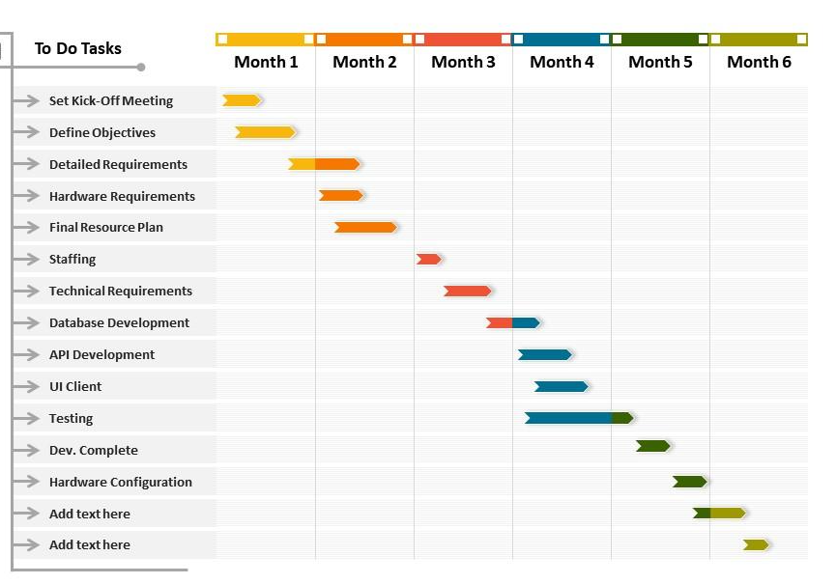*Figure 3.7.1. - Time Line Chart*

1. **Technology Description**

In the development of this proposed system Django Framework of Python is used. Python is a server scripting language, and a powerful tool for making dynamic and interactive Web pages. PHP is a widely-used, free, and efficient alternative to competitors such as Microsoft's ASP. And other technology used are HTML, CSS, JavaScript and MySQL.

* 1. **Features and Limitations of New System**

|  |  |
| --- | --- |
| **Existing System** | **New System** |
| In the previous systems, there is no any feature like system will send mail to the professors if students windows goes out for 5 times while appearing for exam. | This system having this feature, in which faculties automatically get mail about student name and enrolment number, and time of windows out while appearing for exam. |
| In previous systems, securities are not that much good. | This system is developed on the Django Framework of Python, which raises it’s securities and decrease the chances of attack. |
| In previous systems, there is no any feature to conduct coding exam. | This system is able to conduct coding exam, currently this system only support Python language for coding exam but in future we will upgrade it to support multiple exams. |
| Previous systems having a problem of crashing when number of user is more. | In this system, we focus on this part, which decrease the chance of system crash. |

*Table 4.1 – comparison between this to other systems*

1. **Data Flow Diagram**
   1. **Context Level DFD’s**

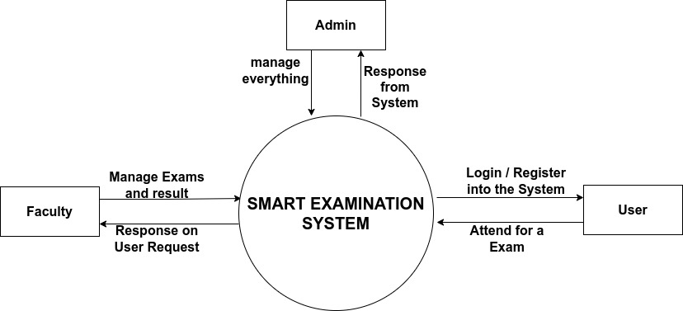*Figure 5.1 – DFD Context Level*

* 1. **Level 1 DFD’s:**

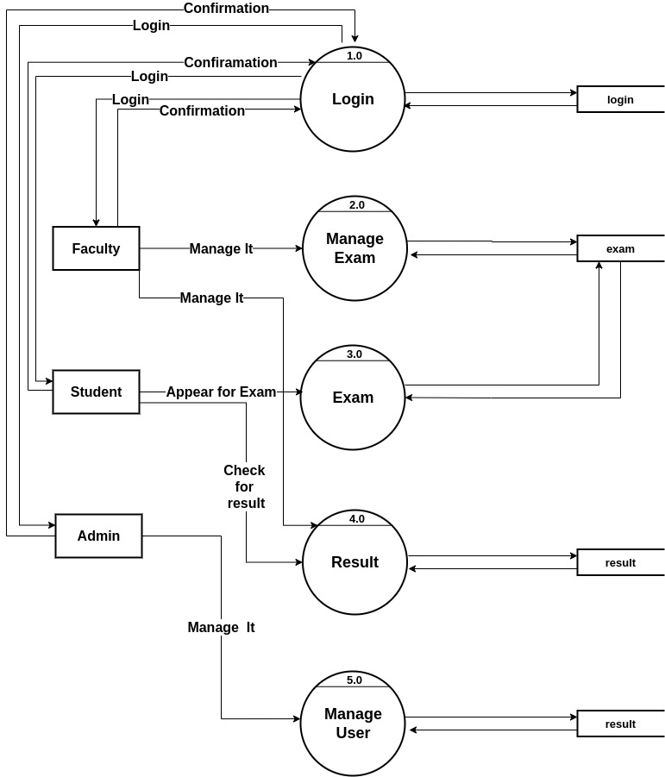*Figure 5.2 – DFD Level 1 diagram*

* 1. **Level 2 DFD’s**

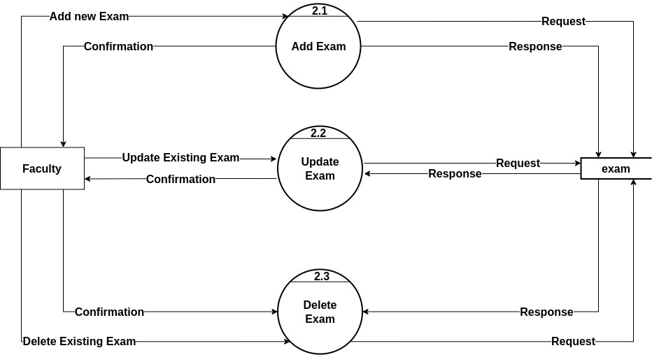*Figure 5.3.1 – DFD Level 2 diagram for manage exam*

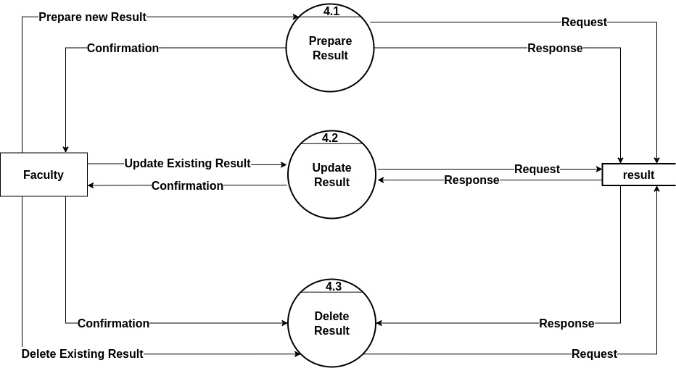*Figure 5.3.2 – DFD Level 2 diagram for manage result*

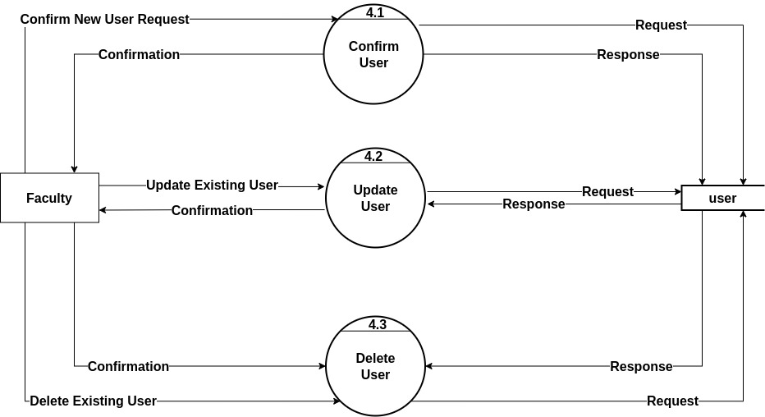*Figure 5.3.3 – DFD Level 2 diagram for manage user*

1. **Use Case Diagram**

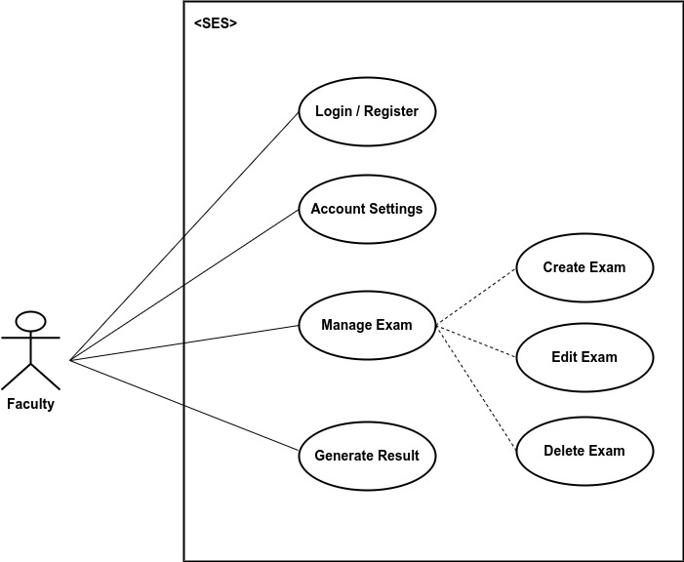

*Figure 6.2 – faculty usecase diagram*

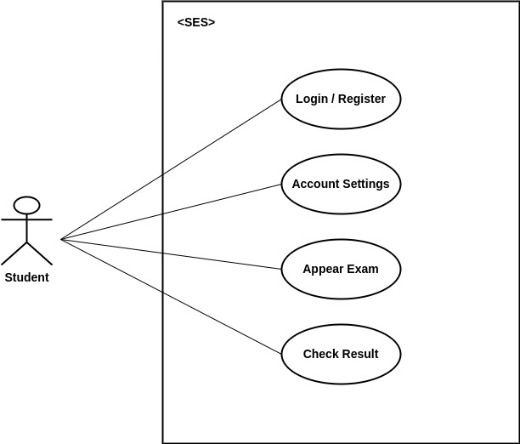

*Figure 6.1 – student usecase diagram*

1. **Class Diagram**

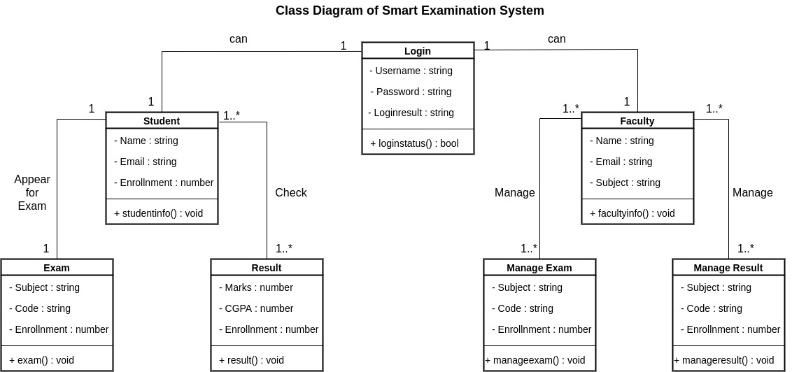*Figure 7 – class diagram*

1. **Activity Diagram**

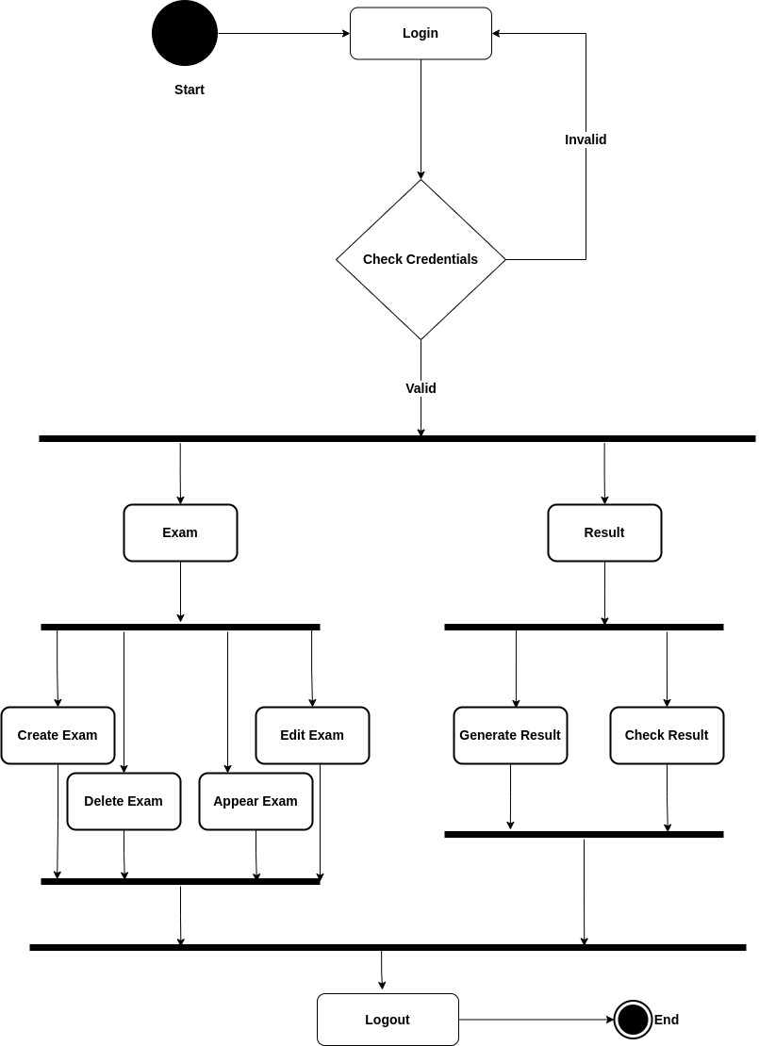*Figure 8 – activity diagram*

* 1. **Description of Activity Diagram**

When System starts, then it ask for login, there is given two option of login, login via Faculty credentials, or login via Student credentials.

If there is a faculty login then he or she can manage all activities of Exam and Result, and if there is student login then he or she can appear for Exam and check his/her Result.

There is also a superuser in this system name as admin, admin can manage all the system features based on the Requirements.

Admin having the access to accept or block any kind of user, other than user, admin can’t register himself in this system, admin account is prebuild account in this system.

1. **E-R Diagram**

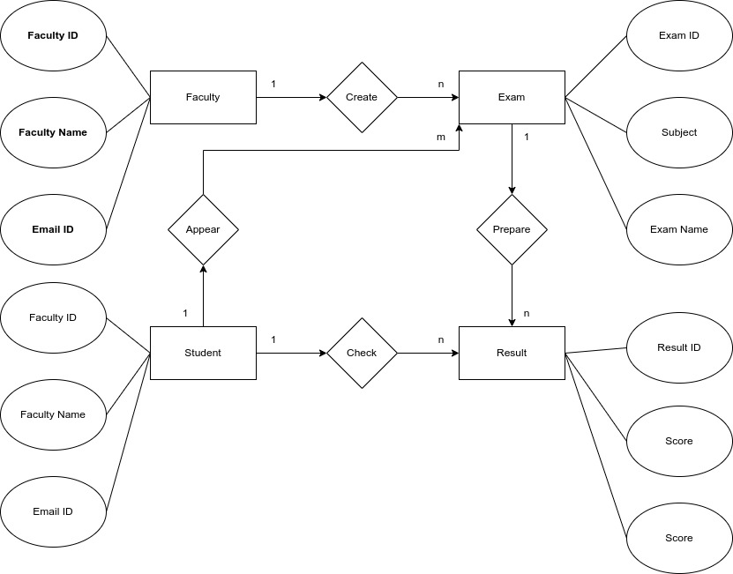*Figure 9 – Entity Relationship (E-R) Diagram*

* 1. **Description of E-R Diagram**

In the smart examination system, every entity is connected to the superuser, and entities like exam and result is connected directly to students and faculty. Entities like department, subject and other small entities are not directly connected to students, but somehow indirectly connected to faculties. Basically in this system, faculties doesn’t having access to delete the existed department and subjects and neither they can edit it, for do so they have to contact superuser. All System is dependencies are on these three users, but superuser takes the main role here.

Somehow this system also store all the logs of every user and they can manage by the superuser, so logs is also in direct relation with superuser but it is in indirect relation with faculty and student.

1. **Data Dictionary**
2. **Login Table**

In this Table System will ask to input correct Username and Password for Login into the System, then user can take benefit of this system.

|  |  |  |  |  |  |  |
| --- | --- | --- | --- | --- | --- | --- |
| **Sr. No** | **Field Name** | **Datatype** | **Size** | **Description** | **Constraint** | **Example** |
|  | Username | varchar | 20 | Unique id of username | Primary Key | amankrs21 |
|  | Password | varchar | 20 | Password for unique id |  | ******* |

*Table 10.1 – Login table fields*

1. **Registration Table**

In this Table System will ask for some necessary data like username, password, subject, email etc. to register the user in this System.

|  |  |  |  |  |  |  |
| --- | --- | --- | --- | --- | --- | --- |
| **Sr. No** | **Field Name** | **Datatype** | **Size** | **Description** | **Constraint** | **Example** |
| 1. | Name | varchar | 20 | Full name of the User |  | amankrs21 |
| 2. | Email | varchar | 20 | Email id will be considered as username. | Primary Key | amankrs21@yahoo.com |
| 3. | Password | varchar | 20 | Password for unique id |  | ******* |
| 4. | Confirm Password | varchar | 20 | Must be same as password |  | ******* |
| 5. | Subject | varchar | 10 | For faculty only |  | Data Structure |

*Table 10.2 – Register Table fields*

1. **Exam Table**In this Table System will use these fields for preparing a exam.

|  |  |  |  |  |  |  |
| --- | --- | --- | --- | --- | --- | --- |
| **Sr. No** | **Field Name** | **Datatype** | **Size** | **Description** | **Constraint** | **Example** |
| 1. | Exam_ID | varchar | 20 | ID of the Exam paper | Primary Key | python21 |
| 2. | Exam Name | varchar | 20 | Name of the Exam |  | Python Class Test |
| 3. | Subject | varchar | 20 | Name of Subject |  | Python |
| 4. | Subject Code | interger | 10 | Subject code of the subject |  | 21345763 |
| 5. | Question_ID | varchar | 20 | ID of every questions while creating it | Foreign key | Q1512 |
| 6. | Faculty Name | varchar | 20 | Faculty name who created the exam |  | Aman Singh |
| 7. | Date_Time | datetime | --- | Date and Time of exam |  | 12-07-2022, 12:00PM |
| 8. | Total_Marks | integer | 3 | Marks of the student |  | 78 |

*Table 10.3 – Exam table fields*

1. **Result Table**In this Table System will show the result of the student by his/her id.

|  |  |  |  |  |  |  |
| --- | --- | --- | --- | --- | --- | --- |
| **Sr. No** | **Field Name** | **Datatype** | **Size** | **Description** | **Constraint** | **Example** |
| 1. | Student_ID | varchar | 20 | ID of the student | Foreign key | student12 |
| 2. | Result ID | varchar | 20 | Result ID | Primary Key | result12 |
| 3. | Total_Marks | varchar | 3 | Marks obtain by student | Foreign Key | ******* |
| 4. | Perentage | varchar | 4 | Total % that a student got |  | ******* |
| 5. | Student name | varchar | 20 | Name of the student from student table |  | Ankit Singh |

*Table 10.4 – Result table fields*

1. **Faculty Table**In this Table, all the information related to faculty is stored in this system, like Name, subject he/she teaches, and many more.

|  |  |  |  |  |  |  |
| --- | --- | --- | --- | --- | --- | --- |
| **Sr. No** | **Field Name** | **Datatype** | **Size** | **Description** | **Constraint** | **Example** |
| 1. | Name | varchar | 20 | Full name of the faculty |  | Aman Singh |
| 2. | faculty_username | varchar | 20 | Username of the faculty must be unique | Primary Key | faculty21 |
| 3. | Password | varchar | 20 | Password for unique id |  | ******* |
| 4. | Confirm Password | varchar | 20 | Must be same as password |  | ******* |
| 5. | Address | varcchar | 100 | Address of the faculty |  | Vadodara |
| 6. | Subject | varchar | 10 | subject that he/she teaches. |  | Data Structure |

*Table 10.5 – Faculty table fields*

1. **Student Table**In this Table, all the information related to student is stored in this system, like Name, stream, in which he/she study and many more.

|  |  |  |  |  |  |  |
| --- | --- | --- | --- | --- | --- | --- |
| **Sr. No** | **Field Name** | **Datatype** | **Size** | **Description** | **Constraint** | **Example** |
| 1. | Name | varchar | 20 | Full name of the Student |  | Ankit Singh |
| 2. | student_username | varchar | 20 | Username of the student | Primary Key | student21 |
| 3. | Password | varchar | 20 | Password for unique id |  | ******* |
| 4. | Confirm Password | varchar | 20 | Must be same as password |  | ******* |
| 5. | Stream | varchar | 10 | Stream in which student is studying |  | BCA |
| 6. | Address | varchar | 100 | Address of the student |  | Vadodara |

*Table 10.6 – Student table fields*

* 1. **Description of Data Dictionary**

In the login Table user have to type username and password to use all the features of this System, for login user must be registered in this system, then they having access of Login. There are only two types of user in this system for login, Faculty and Students. There is also one superuser in this System which is Admin and manages all the System.

For registration user have to fill up all the required details which is asked by the system to fill, such as user’s full name then user’s email id which will be further taken as username, then user’s subject (This is only for faculties), in this subject faculties have to fill for which subjects they are going to take test.

After successful registration user can login into the system from login portal.

1. **Form Design (Screenshots Phase 1 ,2,3,4 & validation’s screenshots)**
   1. **Development Phase -1**

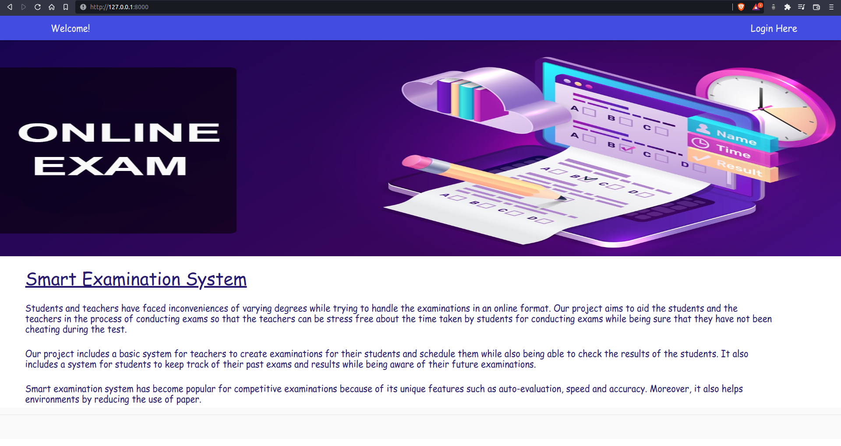*Figure 11.1.1 – Homepage of the system*

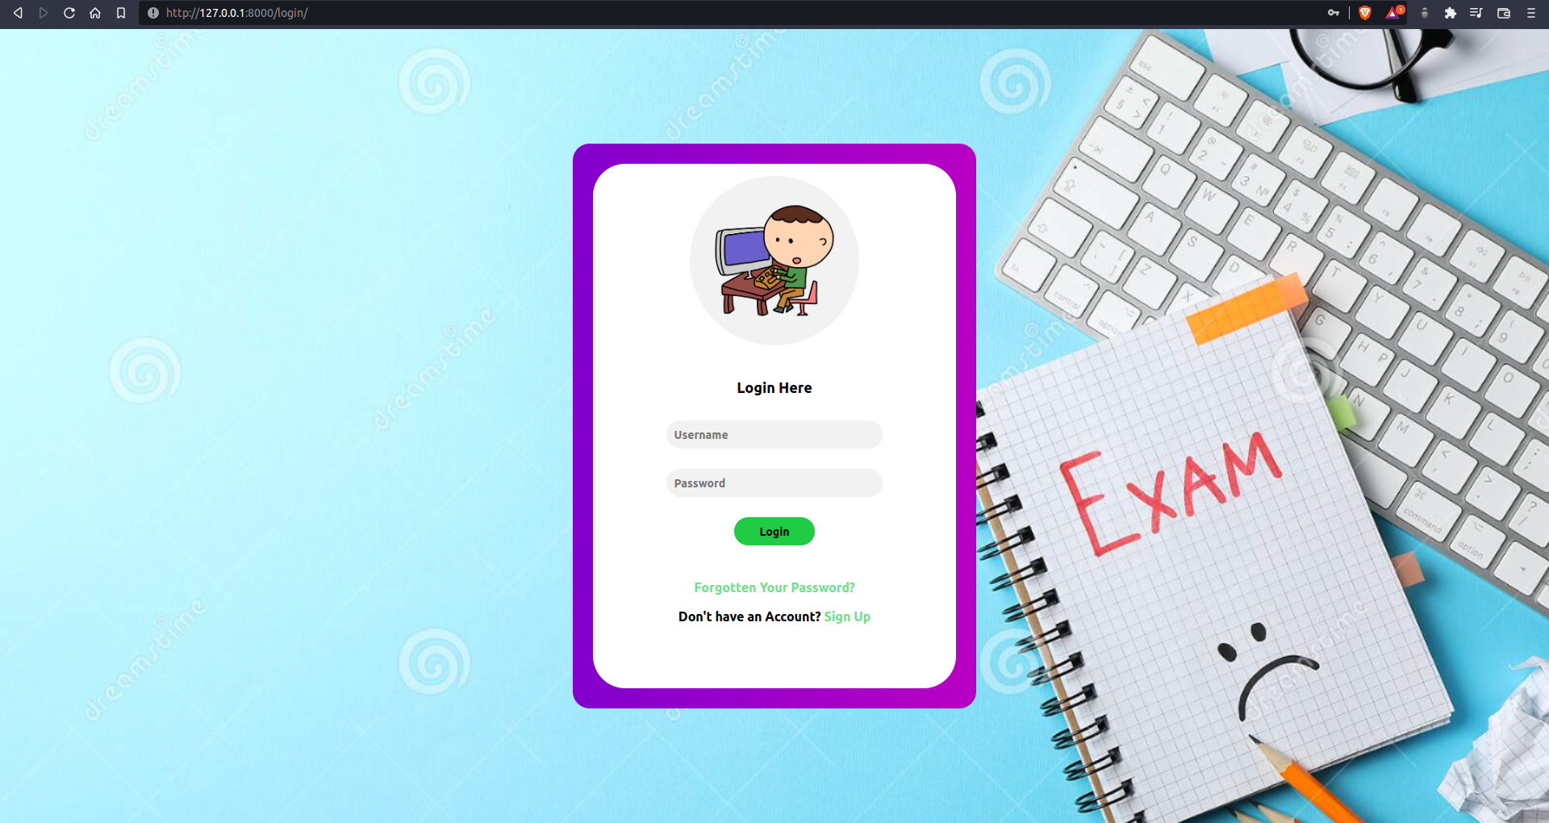*Figure 11.1.2 – Login page of the system*

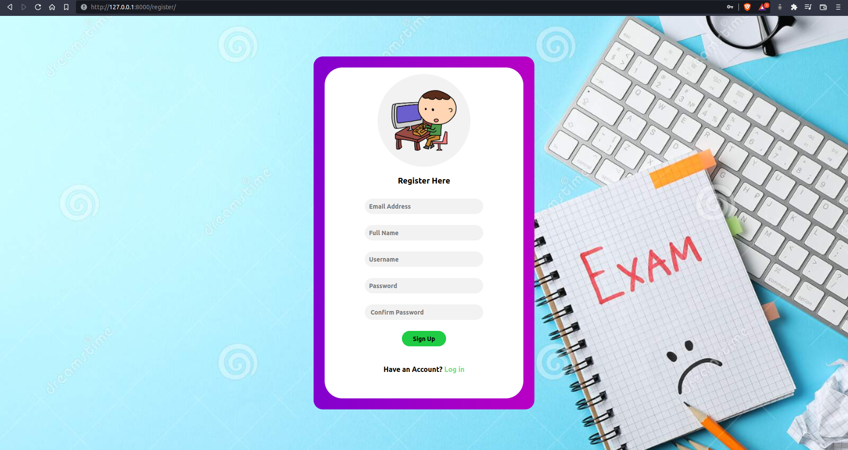

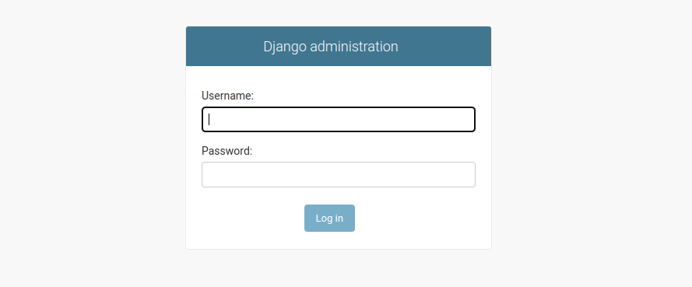*Figure 11.1.3 – registration page of the system*

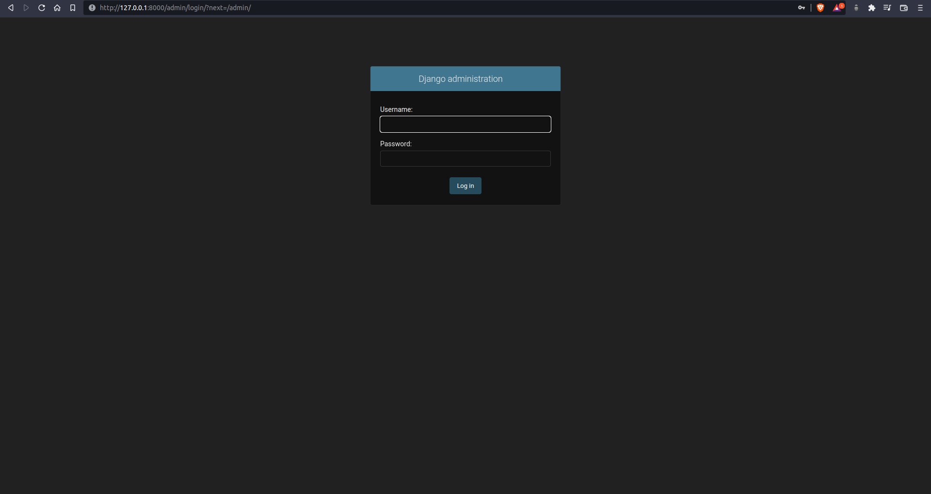*Figure 11.1.4 – Superuser login page of the system*

* 1. **Development Phase -2**

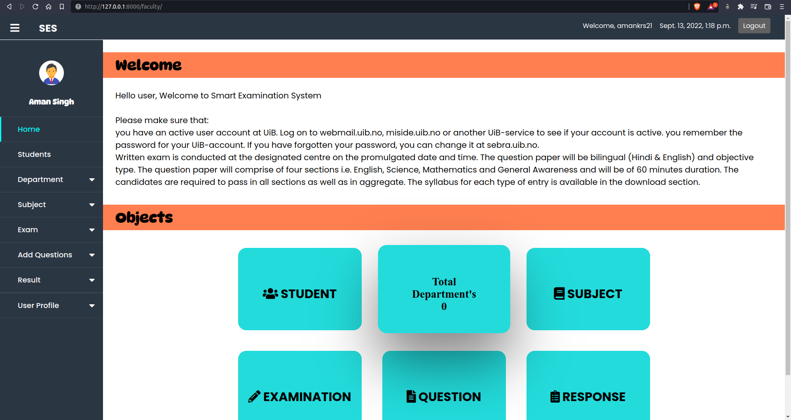

*Figure 11.2.1 – Faculty dashboard*

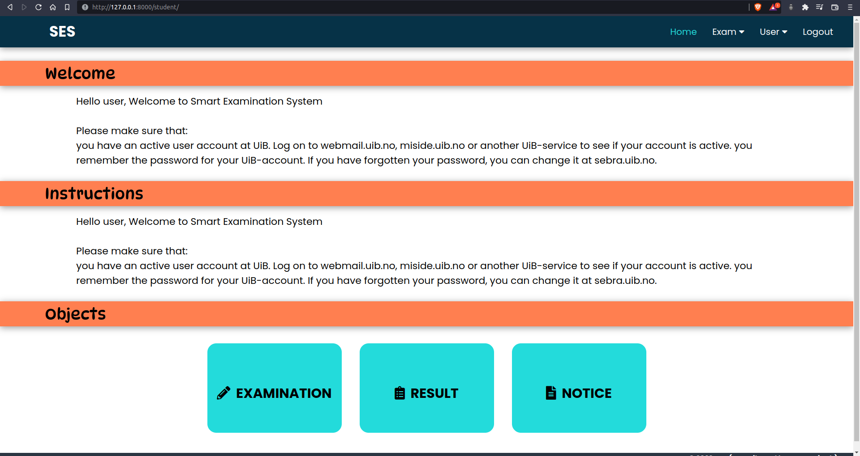*Figure 11.2.2 – Student dashboard*

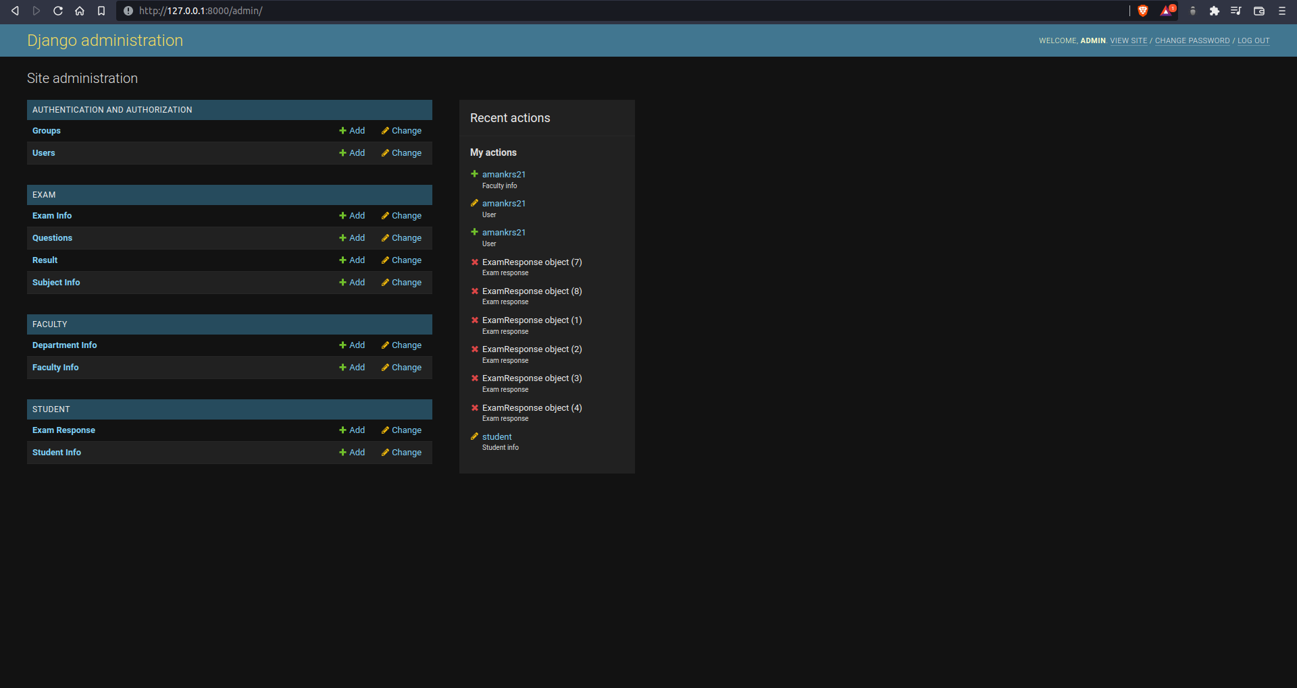*Figure 11.2.3 – Superuser Dashboard*

* 1. **Development Phase -3**

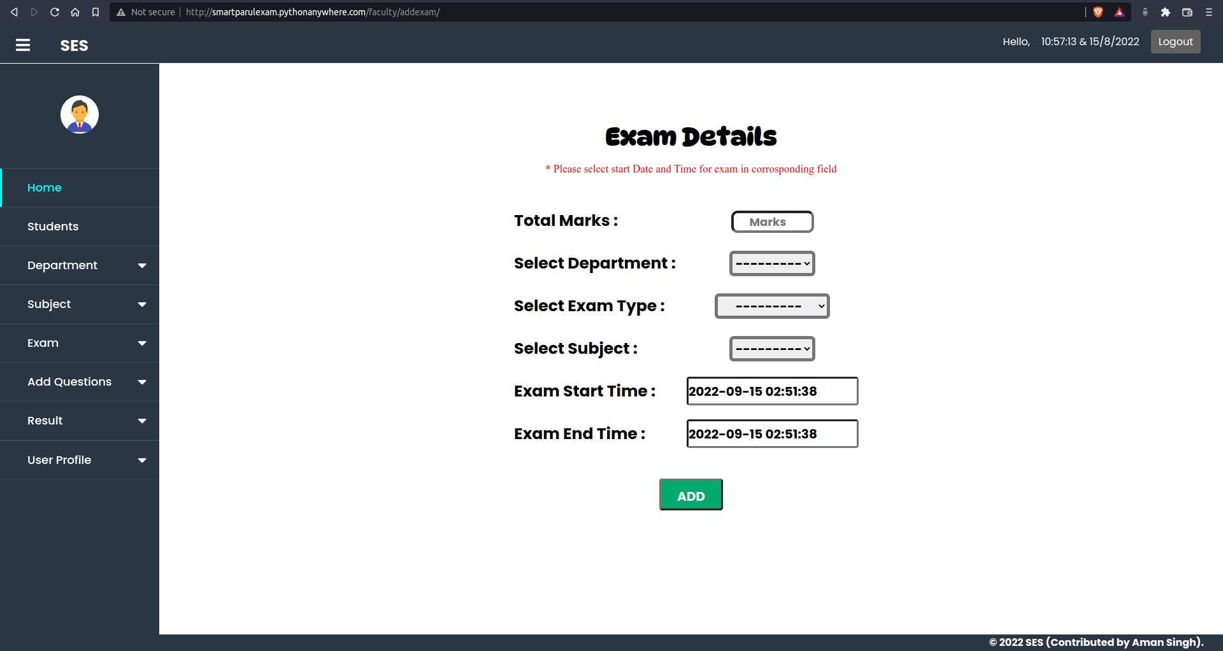*Figure 11.3.1 – Create an Exam at faculty side*

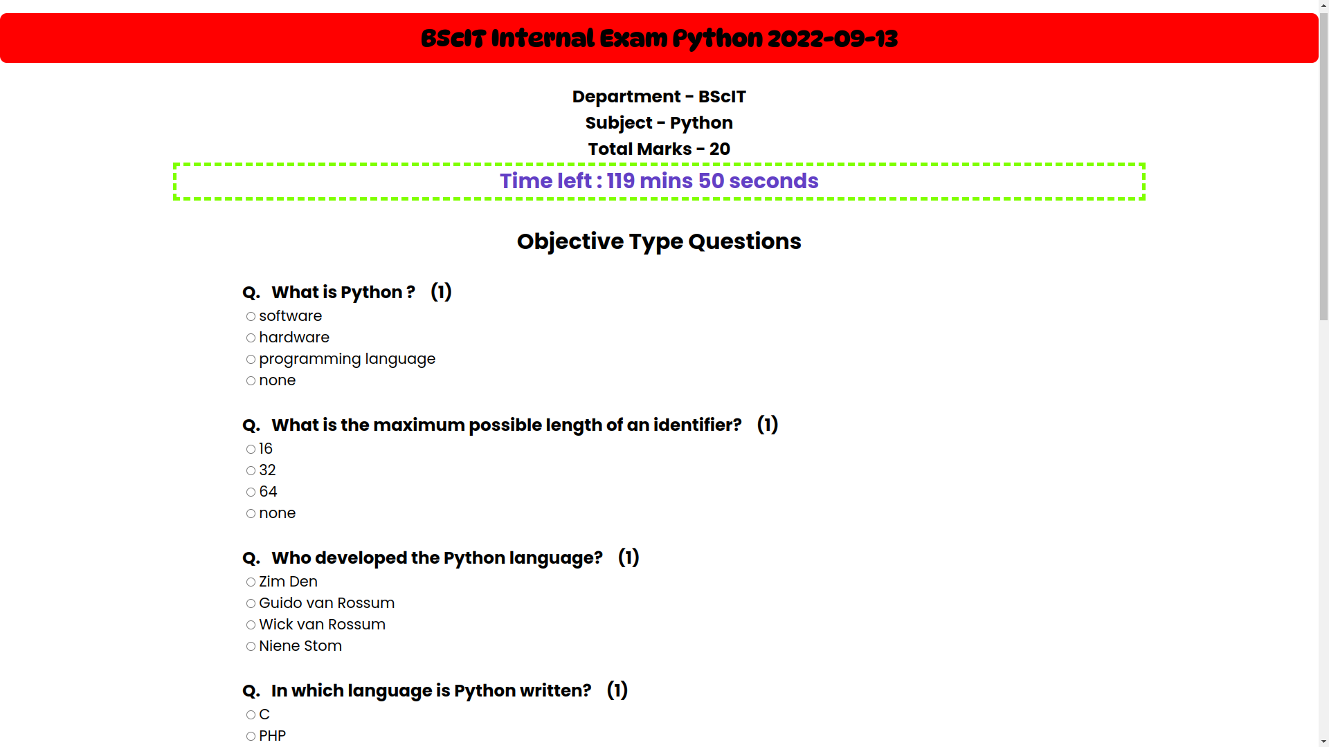*Figure 11.3.2 – Exam view at student side*

* 1. **Development Phase -4**

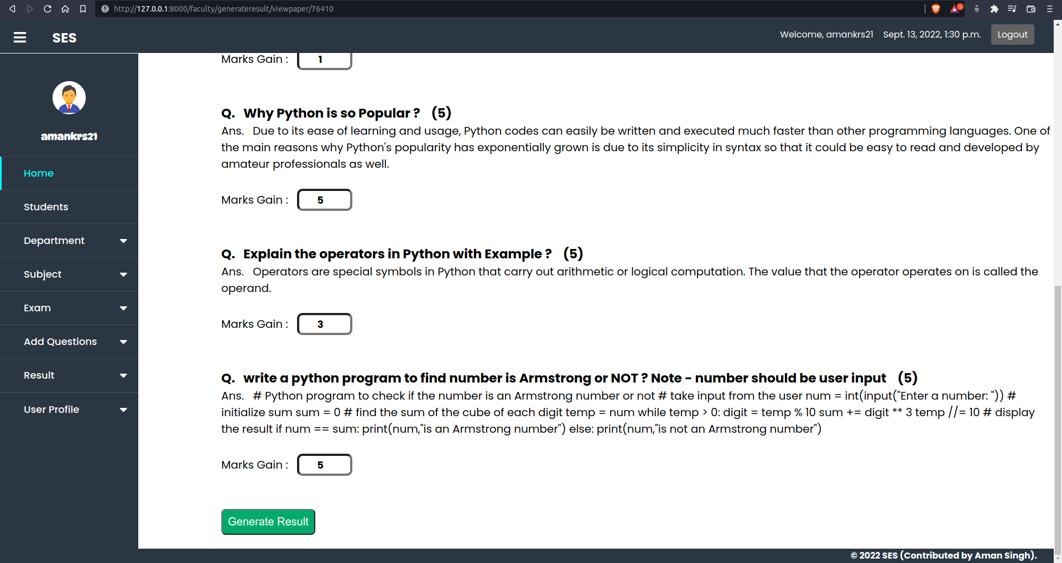*Figure 11.4.1 – check paper & generate result at faculty side*

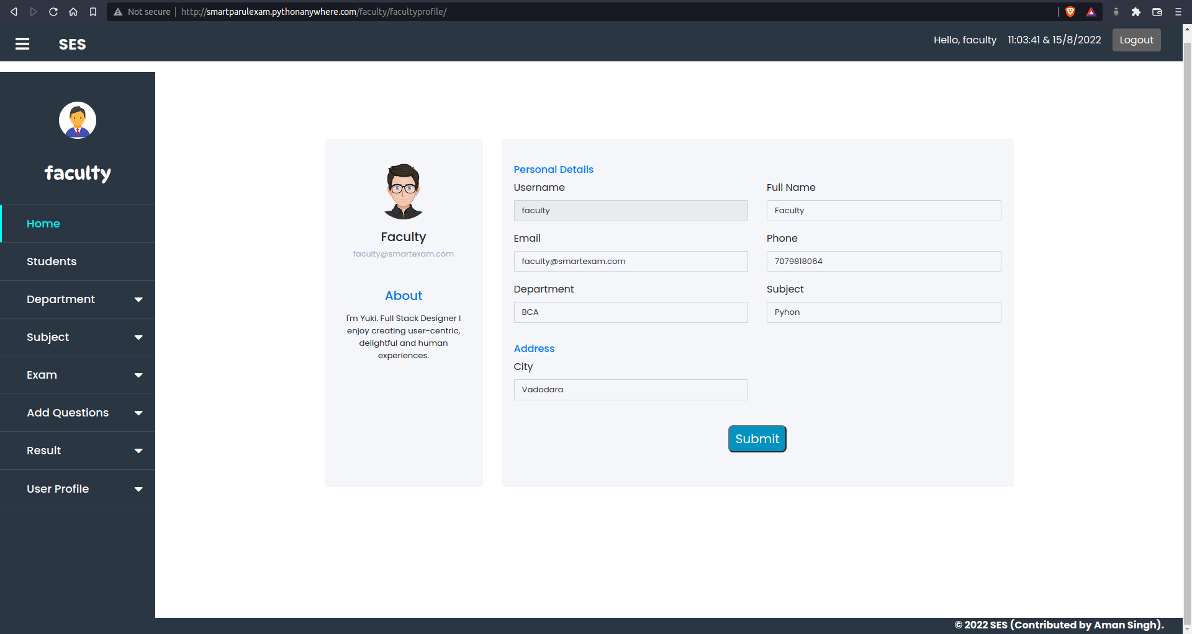*Figure 11.4.2 – Profile view at faculty side*

**12. What is testing?**

Testing documentation is the documentation of artifacts that are created during or before the testing of a software application. Documentation reflects the importance of processes for the customer, individual and organization. Projects which contain all documents have a high level of maturity. Careful documentation can save the time, efforts and wealth of the organization.

Once the test document is ready, the entire test execution process depends on the test document. The primary objective for writing a test document is to decrease or eliminate the doubts related to the testing activities.

**12.1. Importance and types of testing**

We have various types of test document, which are as follows:

* Test scenarios
* Test case
* Test plan
* Requirement traceability matrix(RTM)
* Test strategy
* Test data
* Bug report
* Test execution report

**13. Future Enhancement**

In future enhancement, we will add a feature for supervision time table for Exam, which will auto generate according to the given data.

We will also add a feature, which will generate a PDF file for the result, which can be further print.

In future, we will also add a feature in which student can run their code while giving exam and marks will be given automatically same as objective type question.

We will always try to fix bug time to time, which makes this system more efficient.

We will also try improve the UI as clean as possible that can help user to easily use this system.

We will try to add some automation in this system that can reduce the burden of the faculties.

**14. References & Bibliography**

Website:

1. https://docs.python.org/3/
2. <https://docs.djangoproject.com/en/4.1/>
3. <https://dev.mysql.com/doc/>
4. <https://github.com/>
5. <https://stackoverflow.com/>
6. <https://www.quora.com/>
7. <https://docs.microsoft.com/en-us>
8. <https://www.geeksforgeeks.org/>
9. <https://www.khanacademy.org/>

Book:

1. Django in Advanced
2. SQLite3 Helping Hand

Other Resources:

1. Some Journals
2. YouTube